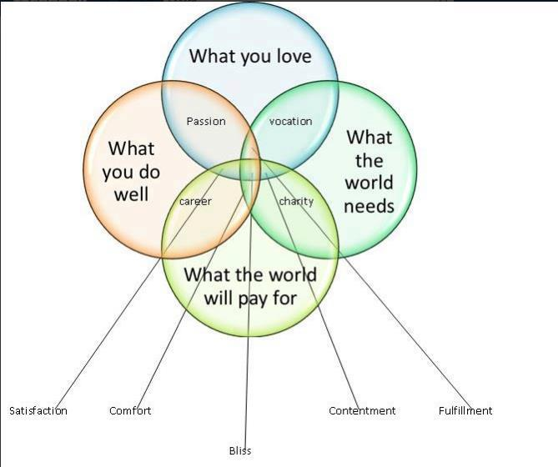

Alex Lightman
Subscribe · April 13

Would you like to know where to find satisfaction, comfort, contentment, fulfillment, and even bliss?
These exquisite gifts of right living are engendered by getting the balance between four things right.
This Venn diagram needs a flow chart to tell you how to get there, and that will come. For now, isn't it nice to know that happy, creative, resourceful states of being are so close at hand?
I recently read the book "The Coming Jobs War" by the chairman of Gallup, who says what the whole world wants is a job. This insight was the result of tens of millions of dollars worth of surveys.
I can't help but think his book would have been better if Gallup had had this diagram: it's not just that people want a job. They want to experience and live within the "space between" that emerge from doing what you love, doing it well, and having it be both what others need and will pay for.
Every child should get this message.
My grandfather, a highly successful painter, sculptor, photographer, and professor of art, used to say, "Blessed is he (or she) who has found his vocation and his avocation for he has found his salvation."
If you get this balance right, you create a little bit more heaven on earth, for you and for others.

