Strike! Rise! Dance! – bell hooks & Eve Ensler

BY LION'S ROAR STAFF| JUNE 18, 2014

http://www.lionsroar.com/strike-rise-dance-bell-hooks-eve-ensler-march-2014/
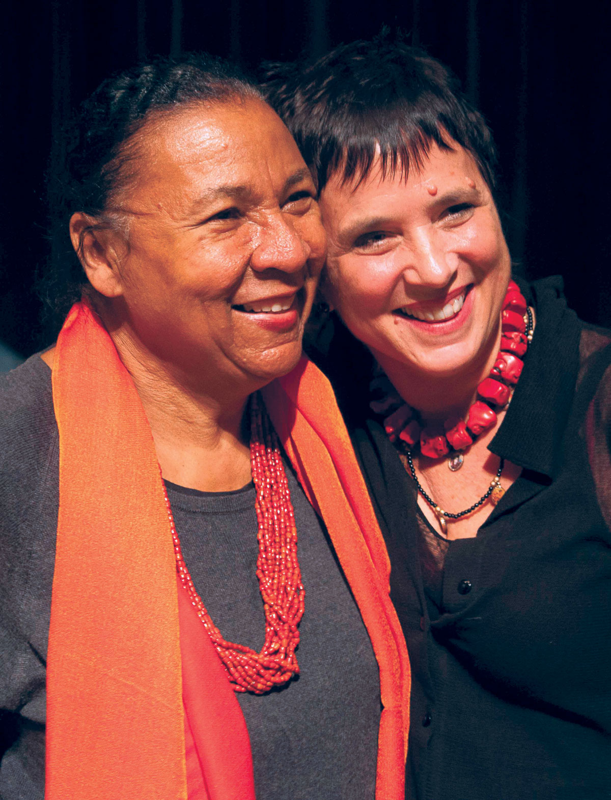
They’re two of the most fearless women we know. bell hooks, a longtime contributor to the Shambhala Sun, is a public intellectual who tells truth to power—and to all of us. Eve Ensler is an artist-activist who has changed women’s lives with her play that became a movement, The Vagina Monologues, and a global celebration of women’s empowerment called One Billion Rising. Here they are in conversation before their dialogue on “Beyond the Body” held at The New School in New York City.
bell hooks: Eve and I agree that love begins with the body. So we want to start our discussion with the whole question of our bodies and where the love is.
Eve Ensler: Maybe I’ll start with how trauma and violence take love out of the body, or at least make it hard to have love in the body. How do we get back into our bodies after we’ve been traumatized? How do we get back to the love in our body? How do we take back our bodies and see them as these stunning miracles that were given to us? Just the way they are.
Because of the methodology of violence, so many of us have become separate from our bodies. We have become objects to ourselves. When I got cancer, and I woke up after nine hours of surgery and had lots of organs and nodes missing, it was the first time in my life I was in my body. I felt how amazing it is to have a body! How incredible it is to have a body! It was like I hadn’t been getting it my whole life. I didn’t get it. I have a body!
bell hooks: It is domination that separates us from our body. People who read my books know I use the phrase “imperialist white supremacist capitalist patriarchy.” [laughter] It’s not so much that I like that phrase, but it connects all the forms of domination that are enslaving us in the world today.
Domination separates us from our bodies no matter which of those forms it takes. Especially, we want to think about white supremacy and patriarchy—forms of domination maintained by violence—that are primarily enacted on the bodies of women and children. White supremacy has divided us along the lines of bodies—black and brown bodies exploited, oppressed, and dominated by white bodies.
Eve’s new book, In the Body of the World, is a memoir of her seven years working with women in Congo. There are not many white women who put their lives on the line to help protect and serve black women’s bodies. In fact, there’s hardly anybody at all who puts their lives on the line for the redemptive saving of black women’s bodies. So, I’m hoping that Eve will open her heart and share with us some of what motivates her.
Eve Ensler: Seven years ago I interviewed an extraordinary man named Dr. Denis Mukwege, who was nominated for the Nobel Peace Prize this year. He is a surgeon and gynecologist who is devoting his life as a Congolese man and a doctor to healing women who were being eviscerated and raped and destroyed in war. Dr. Mukwege asked me, “Would you come and help, because we’re completely alone and we’re drowning? We’re drowning in the rapes; we’re drowning in the violence; we’re drowning.”
I went because he moved me to my core. I went because the injustice that has been wrought on black women’s bodies has always moved me to outrage. I spent weeks with women at Panzi Hospital who had been eviscerated by a war over a mineral that is used in our cellphones. I saw the hundreds and thousands of women’s bodies that were literally being destroyed because of greed.
I was shattered. Something changed in my life forever. The connections we’re talking about were so clear—this colonial, capitalist plundering of a country, and of women’s bodies simultaneously.
I met with many Congolese women and asked them, “How can we serve you? What do you want us to do?” I’ve been taught by activists throughout the world that our job as people of privilege is to go and listen and serve. I have a motto over my desk that says “Shut up and serve.” It’s not our right to dictate what people should do. It’s none of our business. Our job is to find resources so people can do what they do best.
The seven years we’ve worked in Congo have been radically transformative for me. I watched the women determine what they wanted, which became a community for survivors of violence called City of Joy. It is owned by them, run by them, directed by them.
The women who come there are all survivors of gender violence, so the first goal is to transform their enormous suffering. But then we train them to be leaders. This morning I was talking to the extraordinary director of City of Joy, Christine Schuler Deschryver. We just had our fourth class graduate, so that’s now at total of 300 women who have graduated. It’s a miracle that happened because these women had the resources to do what they do best. I think that’s what I’ve learned about service—to be present when you’re needed and disappear when you’re not.
bell hooks: I want to ask you a hard question, Eve. Because of internalized racism, when a white person comes to serve or help people of color, we can put them in a position where we almost worship them and not raise the kinds of critical questions we would ask people of color. So how do you avoid reinforcing the framework of white privilege, for instance through their gratitude? I think it’s a real question for privileged people of all kinds when we go to serve people who are without privilege.
Eve Ensler: It’s something one struggles with. Look, I grew up in a racist world. That conditioning, that story, is in me. So if I am dominating, I want to be called on it. I want to be pointed out. Because we need to keep decolonizing every day.
I’m just beginning to understand the nature of true service, which is how we do the work and yet know we’re not separate from the struggle. Gratitude would mean that I’m somehow separate from the struggle, as opposed to being engaged in it. Why should anyone be grateful to me? I’m part of this same struggle to end capitalist patriarchy and racist practices. That’s what I feel my life is devoted to, so where is the outside and where is the inside? I’m working to get out of the outside and be more in the inside, if that makes sense.
bell hooks: Yet we are affected by how people perceive us. Years ago when I wrote Ain’t I a Woman? I was accused of being homophobic because I didn’t use the word “lesbian.” My lived experience in my little Kentucky town had always been as an advocate, as an ally who could be counted on to stand up for lesbian and gays. But as a nineteen-year-old who was just beginning to create feminist theory, I felt that I shouldn’t say anything about lesbianism because I didn’t know enough about it. I wish I could find the words to talk about how crushed in my little spirit I was by that criticism.
So we don’t always have control over how people respond to us, and that’s where the integrity of one’s intentions are very important. Because—let me be totally honest—a lot of times when you get slapped down, you want to just stay down. Then you have to come back to your commitment to service.
What does it mean to be a servant leader? I feel my life has been committed to militant, visionary feminism, to using whatever insight this mind has to push people—especially women and men of color—to be more engaged in the ways that feminist thinking can alter our lives.
You know that Sweet Honey in the Rock song that says Sometimes you look for friends, and friends just can’t be found, and sometimes you’re standing all alone? That’s when the strength comes in, and it comes from the level of your commitment and the belief that you’re making a difference. For me, that rests on a larger framework of spiritual practice. You keep asking yourself—through meditation, through prayer—“What should I do? Where should I go?”
In the case of Eve, her commitment to go to the Congo is dangerous. It’s about that kind of choice. Many, many times I have thought about Goodman, Chaney, and Schwerner, two wonderful Jewish boys and a black boy who died fighting for voting rights, and asked myself, “What is it I’m willing to put my life on the line for? What am I willing to give?” That is a question we have to continually ask ourselves: What are we willing to give? What are we willing to do?
Eve Ensler: When you serve, there’s ego that’s operating and then there’s the reason you’re there, which is to transform reality. Sometimes they’re at odds. When The Vagina Monologues first started, Rosie Perez and Lisa Gay-Hamilton had this vision to bring it to Harlem and do this incredible women of color production. As we worked on it, all kinds of class and race issues came up. Finally, they came to me and said, “We’ve decided we really don’t want you in the show. We want it to be an all women of color production.”
I remember thinking, “I’ve just been disinvited from my own show—but yeah, absolutely, I will not be in the show.” Because this was a production looking at violence against women of color, and women of color wanted to own that show. Part of me felt really left out, but another part of me said, “The bigger story is operating here. Shut up and serve.”
There’s that lesson again. And in the end it was absolutely the right choice. But my ego wanted to be in that show with all those amazing women! So part of service is learning to let it go. It takes a lot of service and spirituality and coming into one’s center to know the right places on that axis of service.
bell hooks: Most of America’s intimate social relations are governed by racial apartheid. Many white people don’t have people of color in the dailyness of their intimate lives. People may work in an office with a black person, but when they go home their world becomes white again. In that world of intimacy, the deepest forms of racial apartheid continue in our lives.
So, Eve, I want to hear more about your own process of decolonization. Because part of how we get away from imperialist white supremacist capitalist patriarchy is to decolonize our minds. That’s true for all of us, irrespective of our color. What led you to place your body within a sphere of equality with other bodies, and with bodies of color?
Eve Ensler: To a large degree it was being a survivor of violence myself. I came from a white middle-class family in which I was treated with contempt. I was violated regularly. I was raped. I was beaten. I was exiled from that family at a very young age, and I think as a result I’ve always identified with people who have been annihilated and eviscerated, outsiders.
bell hooks: But part of it—and this is where we link up from two very different class and race locations—is your critical reflection on what is taking place in society.
Eve Ensler: Absolutely. I grew up in the 1960s, and I witnessed the incredible injustice that was being done to black people. My witnessing of the racial oppression that existed in this country had, of all the things in my life, including sexism, the deepest impact on me. I felt called to that, but it took me a long time to understand how to be in that struggle in a way where I would be welcomed and could serve in a meaningful way. And be trusted. I think that was a big part of it.
bell hooks: Where does the trust come between dominator and dominated? Between those who have privilege and those who don’t have privilege? Trust is part of what humanizes the dehumanizing relationship, because trust grows and takes place in the context of mutuality. How do we get that when we have profound differences and separations?
Eve Ensler: I’ve always wished we could talk more deeply about the distrust. Sometimes it feels like the Civil Rights movement happened and then there was a blackout. We just stopped communicating. It was as if it all got better—we were living in a post-racial world. As opposed to examining on a much deeper level—on an emotional, political, and spiritual level—what really goes on between people. What are the dynamics, what are the thoughts, what are the feelings?
Congo is a perfect example of this question of trust, because it was probably one of the most colonized and pillaged places in the world. When Dr. Mukwege first invited me to come, he was sure I wouldn’t show up, because everybody else promised they would and then they didn’t. But I did show up, and every time I came back, they would be even more amazed.
It’s taken a long time to develop trust, but walking through that fire of distrust is part of this struggle. To come up against people’s distrust and say, “Okay, it’s completely legitimate distrust, and I’m going to keep showing up in the face of it to see if we can move forward.”
Part of it is understanding that it’s much bigger than you. You’re struggling on a much bigger level for something. And also that when it hurts, it hurts! When people don’t trust you, it does hurt. But that doesn’t mean you don’t keep going.
bell hooks: As I’m sitting here, I’m trying to imagine, where are the spaces of change? In Congo, Eve has helped create the City of Joy, which is one space of enormous change. But in the U.S., black females are up against a media that is so powerful, and our bodies are part of this plantation culture. Where is the space in popular culture where we can talk about the black female body having dignity of presence and being? And not being a body of despair.
Because behind all of this trauma is grief and despair. Young black girls feeling that no one in our society pays attention to the traffic in black women. No one noticed all those black females who disappeared in Cleveland. No one talked about it, but we are still talking about JonBenét Ramsey. Most of us cannot name the four little black girls who were killed in the Birmingham church bombing. We can’t recite the names of Carole Robertson, Denise McNair, Cynthia Wesley, and Addie Mae Collins the way we can rattle off the name of JonBenét. Even small black children know who she is and that something had happened to her. How can we have a world where the bodies of all women, and especially women of color, can be defended and protected?
Eve Ensler: As Terrance McKenna says, culture is not our friend. We have to unplug from the culture and create our revolution where you are. We’ve become passive recipients of a culture that is not only dividing us from each other but from ourselves.
bell hooks: Thich Nhat Hanh says that you are what you are watching. Technology has made it so we consume so many more negative images. When I saw that Miley Cyrus video, which people forced me to watch [laughter], I kept thinking about how ugly the bodies were, how ugly the message was, how degraded sexuality was. Yet everybody was watching. These are things we have to be willing to take the action of stopping.
Eve Ensler: Last year we organized the first worldwide One Billion Rising day to end violence against women and girls. I look at the videos from that all the time, because it inspires me so deeply to see women around the world—particularly women of color—taking up space in places they hadn’t taken space before publicly. Dancing and moving and being alive. Being sexual and being free and being beautiful and not being contained and not being oppressed and not being stopped and not having their energy distorted or muted or misinterpreted or tamed or undone.
So how do we create spaces—through art, through energy, through writing, through discourse—where women can come into their bodies and their power? I look at those videos from India and Africa, where women were dancing for hours. You can see the energy that got unplugged from the gateways, which had been filled with trauma. To see them come into that aliveness gives me so much hope for the possibility of creating that in the future.
bell hooks: But the reclamation of the body also has to be a place where we acknowledge that the body is just that, the body. Love begins with the body, but where do we take that love? The act of loving our bodies as women of color is itself an act of resistance and decolonization. But then what do we do? Where do we go? How do we live in a world that isn’t ready for us?
I would suggest that we have to invent our own psychic cities of joy. We have to create spaces where we’re not looking for the dominant culture to validate us. As people of color, we know white supremacy exists, but we’re still looking to that world to give us affirmation. We don’t want to acknowledge that, as part of our liberation struggle, we may have to create other venues where there isn’t necessarily a lot of money to be had.
So let’s think about the role of cooperation in helping us create a solidarity of resistance that allows the colonizing process to be challenged, that lets decolonization be there every day in our lives. Decolonization is a healing practice that has to be ongoing. They tell you in AA that your recovery is ongoing, and for those of us who live in the belly of imperialist white supremacist capitalist patriarchy, our recovery is also ongoing. Our decolonization is ongoing and we have to remain critically vigilant.
Question: Are there any practices that you recommend—meditation or prayer—to bring us back into our bodies and our spirits?
bell hooks: I really believe in great therapy. [laughter] Any time you have good therapy that is healing, it brings you into your body. It answers the questions that your body raises. And I definitely depend on spiritual practice, meditation, affirmation, as part of that healing.
Eve Ensler: I really believe in dancing. [laughter] If the women of Congo have taught me anything, it is that dancing is the answer to trauma. The women of Congo dance like no other people I’ve ever seen in the world—they dance in a way that is transformative on the cellular level. I’ve seen a woman who’s gone through terrible trauma, and the women gather with her, and they dance and they dance. The fact that we put dancing down is an indication of the patriarchal confines we’re in. I think people should dance all day long. I think it should be a part of what we do.

