She Who Hears the Cries of the World
BY CHRISTINA FELDMAN| DECEMBER 3, 2015
http://www.lionsroar.com/she-who-hears-the-cries-of-the-world/

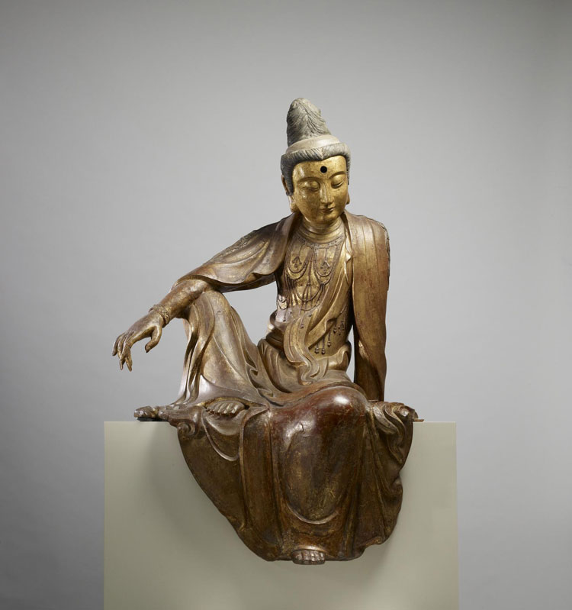

The Buddhist path isn’t just about the accumulation of wisdom. It equally requires the development of compassion—an intelligent sympathy for the suffering of all beings and the heartfelt wish to liberate them. In Buddhist iconography, this compassion is embodied in the bodhisattva Kuan Yin, who is said to manifest wherever beings need help. Engendering such compassion is not only good for others, says Christina Feldman, it is also good for us. By putting others first, we loosen the bonds of our self-fixation, and in doing so, inch closer to our own liberation.
Compassion is no stranger to any of us: we know what it feels like to be deeply moved by the pain and suffering of others. All people receive their own measure of sorrow and struggle in this life. Bodies age, health becomes fragile, minds can be beset by confusion and obsession, hearts are broken. We see many people asked to bear the unbearable—starvation, tragedy, and hardship beyond our imagining. Our loved ones experience illness, pain, and heartache, and we long to ease their burden.
The human story is a story of love, redemption, kindness, and generosity. It is also a story of violence, division, neglect, and cruelty. Faced with all of this, we can soften, reach out, and do all we can to ease suffering. Or we can choose to live with fear and denial—doing all we can to guard our hearts from being touched, afraid of drowning in this ocean of sorrow.
Again and again we are asked to learn one of life’s clearest lessons: that to run from suffering—to harden our hearts, to turn away from pain—is to deny life and to live in fear. So, as difficult as it is to open our hearts toward suffering, doing so is the most direct path to transformation and liberation.
Compassion and wisdom are at the heart of the path of the Buddha. In the early Buddhist stories we find young men and women asking the same questions we ask today: How can we respond to the suffering that is woven into the very fabric of life? How can we discover a heart that is truly liberated from fear, anger, and alienation? Is there a way to discover a depth of wisdom and compassion that can genuinely make a difference in this confused and destructive world?
We may be tempted to see compassion as a feeling, an emotional response we occasionally experience when we are touched by an encounter with acute pain. In these moments of openness, the layers of our defenses crumble; intuitively we feel an immediacy of response and we glimpse the power of nonseparation. Milarepa, a great Tibetan sage, expressed this when he said, “Just as I instinctively reach out to touch and heal a wound in my leg as part of my own body, so too I reach out to touch and heal the pain in another as part of this body.” Too often these moments of profound compassion fade, and once more we find ourselves protecting, defending, and distancing ourselves from pain. Yet they are powerful glimpses that encourage us to question whether compassion can be something more than an accident we stumble across.
No matter how hard we try, we can’t make ourselves feel com–passionate. But we can incline our hearts toward compassion. In one of the stories in the early Buddhist literature, the ascetic Sumedha reflects on the vast inner journey required to discover unshakeable wisdom and compassion. He describes compassion as a tapestry woven of many threads: generosity, virtue, renunciation, wisdom, energy, patience, truthfulness, determination, loving-kindness, and equanimity. When we embody all of these in our lives, we develop the kind of compassion that has the power to heal suffering.
A few years ago, an elderly monk arrived in India after fleeing from prison in Tibet. Meeting with the Dalai Lama, he recounted the years he had been imprisoned, the hardship and beatings he had endured, the hunger and loneliness he had lived with, and the torture he had faced.
At one point the Dalai Lama asked him, “Was there ever a time you felt your life was truly in danger?”
The old monk answered, “In truth, the only time I truly felt at risk was when I felt in danger of losing compassion for my jailers.”
Hearing stories like this, we are often left feeling skeptical and bewildered. We may be tempted to idealize both those who are compassionate and the quality of compassion itself. We imagine these people as saints, possessed of powers inaccessible to us. Yet stories of great suffering are often stories of ordinary people who have found greatness of heart. To discover an awakened heart within ourselves, it is crucial not to idealize or romanticize compassion. Our compassion simply grows out of our willingness to meet pain rather than to flee from it.
We may never find ourselves in situations of such peril that our lives are endangered; yet anguish and pain are undeniable aspects of our lives. None of us can build walls around our hearts that are invulnerable to being breached by life. Facing the sorrow we meet in this life, we have a choice: Our hearts can close, our minds recoil, our bodies contract, and we can experience the heart that lives in a state of painful refusal. We can also dive deeply within ourselves to nurture the courage, balance, patience, and wisdom that enable us to care.
If we do so, we will find that compassion is not a state. It is a way of engaging with the fragile and unpredictable world. Its domain is not only the world of those you love and care for, but equally the world of those who threaten us, disturb us, and cause us harm. It is the world of the countless beings we never meet who are facing an unendurable life. The ultimate journey of a human being is to discover how much our hearts can encompass. Our capacity to cause suffering as well as to heal suffering live side by side within us. If we choose to develop the capacity to heal, which is the challenge of every human life, we will find our hearts can encompass a great deal, and we can learn to heal—rather than increase—the schisms that divide us from one another.
In the first century in northern India, probably in what is now part of Afghanistan, the Lotus Sutra was composed. One of the most powerful texts in the Buddhist tradition, it is a celebration of the liberated heart expressing itself in a powerful and boundless compassion, pervading all corners of the universe, relieving suffering wherever it finds it.
When the Lotus Sutra was translated into Chinese, Kuan Yin, the “one who hears the cries of the world,” emerged as an embodiment of compassion that has occupied a central place in Buddhist teaching and practice ever since. Over the centuries Kuan Yin has been portrayed in a variety of forms. At times she is depicted as a feminine presence, face serene, arms outstretched, and eyes open. At times she holds a willow branch, symbolizing her resilience—able to bend in the face of the most fierce storms without being broken. At other times she is portrayed with a thousand arms and hands, each with an open eye in its center, depicting her constant awareness of anguish and her all-embracing responsiveness. Sometimes she takes the form of a warrior armed with a multitude of weapons, embodying the fierce aspect of compassion committed to uprooting the causes of suffering. A protector and guardian, she is fully engaged with life.
To cultivate the willingness to listen deeply to sorrow wherever we meet it is to take the first step on the journey of compassion. Our capacity to listen follows on the heels of this willingness. We may make heroic efforts in our lives to shield ourselves from the anguish that can surround us and live within us, but in truth a life of avoidance and defense is one of anxiety and painful separation.
True compassion is not forged at a distance from pain but in its fires. We do not always have a solution for suffering. We cannot always fix pain. However, we can find the commitment to stay connected and to listen deeply. Compassion does not always demand heroic acts or great words. In the times of darkest distress, what is most deeply needed is the fearless presence of a person who can be wholeheartedly receptive.
It can seem to us that being aware and opening our hearts to sorrow makes us suffer more. It is true that awareness brings with it an increased sensitivity to our inner and outer worlds. Awareness opens our hearts and minds to a world of pain and distress that previously only glanced off the surface of consciousness, like a stone skipping across water. But awareness also teaches us to read between the lines and to see beneath the world of appearances. We begin to sense the loneliness, need, and fear in others that was previously invisible. Beneath words of anger, blame, and agitation we hear the fragility of another person’s heart. Awareness deepens because we hear more acutely the cries of the world. Each of those cries has written within it the plea to be received.
Awareness is born of intimacy. We can only fear and hate what we do not understand and what we perceive from a distance. We can only find compassion and freedom in intimacy. We can be afraid of intimacy with pain because we are afraid of helplessness; we fear that we don’t have the inner balance to embrace suffering without being overwhelmed. Yet each time we find the willingness to meet affliction, we discover we are not powerless. Awareness rescues us from helplessness, teaching us to be helpful through our kindness, patience, resilience, and courage. Awareness is the forerunner of understanding, and understanding is the prerequisite to bringing suffering to an end.
Shantideva, a deeply compassionate master who taught in India in the eighth century, said, “Whatever you are doing, be aware of the state of your mind. Accomplish good; this is the path of compassion.” How would our life be if we carried this commitment into all of our encounters? What if we asked ourselves what it is we are dedicated to when we meet a homeless person on the street, a child in tears, a person we have long struggled with, or someone who disappoints us? We cannot always change the heart or the life of another person, but we can always take care of the state of our own mind. Can we let go of our resistance, judgments, and fear? Can we listen wholeheartedly to understand another person’s world? Can we find the courage to remain present when we want to flee? Can we equally find the compassion to forgive our wish to disconnect? Compassion is a journey. Every step, every moment of cultivation, is a gesture of deep wisdom.
Living in Asia for several years, I encountered an endless stream of people begging in the streets. Faced with a forlorn, gaunt child I would find myself judging a society that couldn’t care for its deprived children. Sometimes I would feel irritated, perhaps dropping a few coins into the child’s hand while ensuring I kept my distance from him. I would debate with myself whether I was just perpetuating the culture of begging by responding to the child’s pleas. It took me a long time to understand that, as much as the coins may have been appreciated, they were secondary to the fact that I rarely connected to the child.
As the etymology of the word indicates, “compassion” is the ability to “feel with,” and that involves a leap of empathy and a willingness to go beyond the borders of our own experience and judgments. What would it mean to place myself in the heart of that begging child? What would it be like to never know if I will eat today, depending entirely on the handouts of strangers? Journeying beyond our familiar borders, our hearts can tremble; then, we have the possibility of accomplishing good.
Milarepa once said, “Long accustomed to contemplating compassion, I have forgotten all difference between self and other.” Genuine compassion is without boundaries or hierarchies. The smallest sorrow is as worthy of compassion as the greatest anguish. The heartache we experience in the face of betrayal asks as much for compassion as a person caught in the midst of tragedy. Those we love and those we disdain ask for compassion; those who are blameless and those who cause suffering are all enfolded in the tapestry of compassion. An old Zen monk once proclaimed, “O, that my monk’s robes were wide enough to gather up all of the suffering in this floating world.” Compassion is the liberated heart’s response to pain wherever it is met.
When we see those we love in pain, our compassion is instinctive. Our heart can be broken. It can also be broken open. We are most sorely tested when we are faced with a loved one’s pain that we cannot fix. We reach out to shield those we love from harm, but life continues to teach us that our power has limits. Wisdom tells us that to insist that impermanence and frailty should not touch those we love is to fall into the near enemy of compassion, which is attachment to result and the insistence that life must be other than it actually is.
Compassion means offering a refuge to those who have no refuge. The refuge is born of our willingness to bear what at times feels unbearable—to see a loved one suffer. The letting go of our insistence that those we love should not suffer is not a relinquishment of love but a release of illusion—the illusion that love can protect anyone from life’s natural rhythms. In the face of a loved one’s pain, we are asked to understand what it means to be steadfast and patient in the midst of our own fear. In our most intimate relationships, love and fear grow simultaneously. A compassionate heart knows this to be true and does not demand that fear disappear. It knows that only in the midst of fear can we begin to discover the fearlessness of compassion.
Some people, carrying long histories of a lack of self-worth or denial, find it most difficult to extend compassion toward themselves. Aware of the vastness of suffering in the world, they may feel it is self-indulgent to care for their aching body, their broken heart, or their confused mind. Yet this too is suffering, and genuine compassion makes no distinction between self and other. If we do not know how to embrace our own frailties and imperfections, how do we imagine we could find room in our heart for anyone else?
The Buddha once said that you could search the whole world and not find anyone more deserving of your love and compassion than yourself. Instead, too many people find themselves directing levels of harshness, demand, and judgment inward that they would never dream of directing toward another person, knowing the harm that would be incurred. They are willing to do to themselves what they would not do to others.
In the pursuit of an idealized compassion, many people can neglect themselves. Compassion “listens to the cries of the world,” and we are part of that world. The path of compassion does not ask us to abandon ourselves on the altar of an idealized state of perfection. A path of healing makes no distinctions: within the sorrow of our own frustrations, disappointments, fears, and bitterness, we learn the lessons of patience, acceptance, generosity, and ultimately, compassion.
The deepest compassion is nurtured in the midst of the deepest suffering. Faced with the struggle of those we love or those who are blameless in this world, compassion arises instinctively. Faced with people who inflict pain upon others, we must dive deep within ourselves to find the steadfastness and understanding that enables us to remain open. Connecting with those who perpetrate harm is hard practice, yet compassion is somewhat shallow if it turns away those who—lost in ignorance, rage, and fear—harm others. The mountain of suffering in the world can never be lessened by adding yet more bitterness, resentment, rage, and blame to it.
Thich Nhat Hanh, the beloved Vietnamese teacher, said, “Anger and hatred are the materials from which hell is made.” It is not that the compassionate heart will never feel anger. Faced with the terrible injustice, oppression, and violence in our world, our hearts tremble not only with compassion but also with anger. A person without anger may be a person who has not been deeply touched by harmful acts that scar the lives of too many people. Anger can be the beginning of abandonment or the beginning of commitment to helping others.
We can be startled into wakefulness by exposure to suffering, and this wakefulness can become part of the fabric of our own rage, or part of the fabric of wise and compassionate action. If we align ourselves with hatred, we equally align ourselves with the perpetrators of harm. We can also align ourselves with a commitment to bringing to an end the causes of suffering. It is easy to forget the portrayal of Kuan Yin as an armed warrior, profoundly dedicated to protecting all beings, fearless and resolved to bring suffering to an end.
Rarely are words and acts of healing and reconciliation born of an agitated heart. One of the great arts in the cultivation of compassion is to ask if we can embrace anger without blame. Blame agitates our hearts, keeps them contracted, and ultimately leads to despair. To surrender blame is to maintain the discriminating wisdom that knows clearly what suffering is and what causes it. To surrender blame is to surrender the separation that makes compassion impossible.
Compassion is not a magical device that can instantly dispel all suffering. The path of compassion is altruistic but not idealistic. Walking this path we are not asked to lay down our life, find a solution for all of the struggles in this world, or immediately rescue all beings. We are asked to explore how we may transform our own hearts and minds in the moment. Can we understand the transparency of division and separation? Can we liberate our hearts from ill will, fear, and cruelty? Can we find the steadfastness, patience, generosity, and commitment not to abandon anyone or anything in this world? Can we learn how to listen deeply and discover the heart that trembles in the face of suffering?
The path of compassion is cultivated one step and one moment at a time. Each of those steps lessens the mountain of sorrow in the world.

