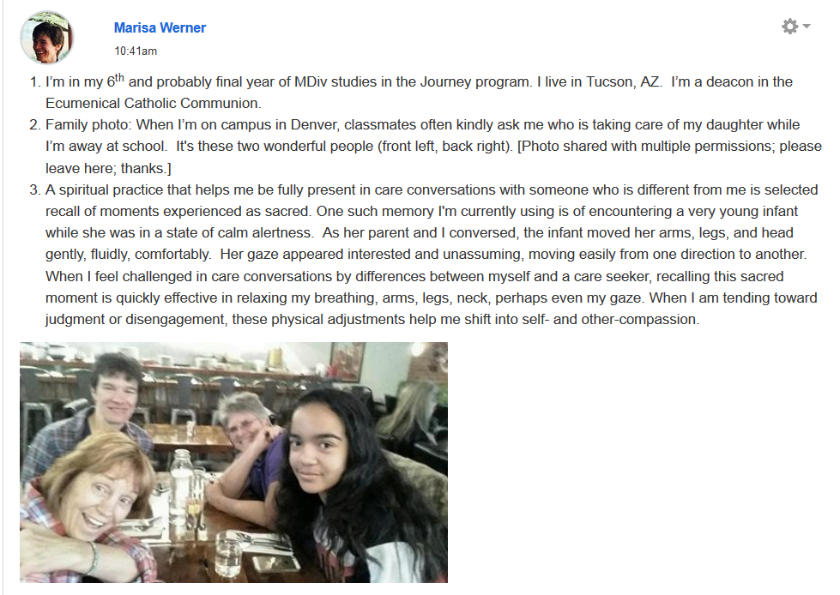
PS Marisa gave us permission to include this photo in her introduction

