G*d & Tupac
IST 3113 1 Spring 2017 6-7 February 2019 13.00P-17.00P / 08.00A-12.00PIliff Hall 201 Iliff School of Theology

JENNIFER S. LEATH & TEF POE
office hours: by appointment
jleath@iliff.edu

Introductory Tupac Video

COURSE DESCRIPTION
A rapper, recording artist, activist, and philosopher, Tupac Shakur has withstood the test of time as an icon through whom those who study him and his work are challenged to believe, think, live, and act differently. This course will provide an in-depth introduction to the life and work of Tupac Shakur through an engagement with his music, his writings, writings about him, his family, and his faith.
COURSE OBJECTIVES
- To gain an in-depth knowledge of the life and work of Tupac Shakur.
- To gain a sense of the ways that Shakur’s legacy persists in the life and work of a contemporary rap artist and one who lives a life of activism in and through Tef Poe.
- To engage a variety of interdisciplinary literatures, with an emphasis on primary and secondary historical material, to cull common religious principles and to articulate formulations of G*d.
- To develop creative and integrative research skills that enable students to identify the strengths and limitations of traditional theologies and raciologies.
- To imagine the common and distinct futures of rap and religion.
COURSE REQUIREMENTS
- Completion of reading, Viewing, and Listening assignments.
- Active participation, punctual attendance, and responsiveness to online prompts from teachers and fellow students. Note that you will be asked and expected to respond in various ways to the weekly lectures. You will also be expected to respond to your peers' "The Man & The Music" prompts weekly by Friday as well as to prompts indicated in the lecture modules.
- Online “The Man & The Music” discussion prompts for of one of the ten weeks of class. Select one Tupac song that connects to the themes for the week and the course. Begin a discussion thread with the following by Wednesday of your week: (1) a Youtube link to a version of the song you have selected; (2) an explanation of why you have selected the song; (3) historical, critical, and analytical contextualization of the song with respect to the time it was written and/or produced as well as the cultural context in which it was originally located; (4) an explanation of how the song is related to the week's readings and media; (5) a question prompt for your classmates that the song inspires.
- “Legacy” Presentations. Through a multimedia platform that you can post online and share with your peers by 1 March 2019 at 9pm: (1) identify what you believe to be the most important aspect of Tupac's legacy and explain why you believe it to be so; (2) articulate a thorough and descriptive articulation of Tupac's theoethics, drawing from course material; (3) imagine and evaluate the vision of justice Tupac -- and his legacy commend; (4) utilize and incorporate the interdisciplinary course materials; (5) creatively engage the online “classroom."
- Final Papers. Final papers are due at 9pm via email on 8 March. Each paper should CREATIVELY (in 15-20 pages, double spaced, Times New Roman Font, Chicago Citation Format): (1) identify and engage a theme connected to Tupac Shakur with a clear thesis that you support through the body of your writing; this theme should be distinct from what you engage as the most important aspect of Tupac's legacy in the "Legacy" presentations; (2) identify and explain a working definition of G*d in relation to the readings and materials covered in the weeks prior; (3) identify and explain one expression of activism in the assigned readings and materials and how this expression relates to a) the theme you have identified, b) the definition of G*d you have provided and c) your understanding of Tupac's character; (4) reflect on the way music and/or artistry inform your sense of G*d & Tupac.
EVALUATION
- You will be graded according to Iliff standards on a letter grading scale. For more information see: www.iliff.edu
- Your grade will be determined as follows:
- Preparedness, Participation, Attendance: 40%
- “The Man & The Music”: 40%
- “Legacy Presentations”: 20% each
- Final Paper: 20%
OTHER IMPORTANT MATTERS
- DO NOT plagiarize! If you have any questions about whether or not what you are doing is plagiarism, go to www.iliff.edu. If you are still unsure, ask before submitting your work.
- If you are unable to complete the assignments due to physical or mental health reasons, please notify me.
COURSE READINGS

Ardis, Angela. Inside A Thug’s Heart. New York: Kensington, 2004.
Dyson, Michael Eric. Holler If You Hear Me: Searching For Tupac Shakur. First Edition edition. New York: Civitas
Books, 2001.
Gobi, and Afeni Shakur. Thru My Eyes: Thoughts on Tupac Amaru Shakur in Pictures and Words. New York: Atria Books,
2005.
Guy, Jasmine. Afeni Shakur: Evolution of a Revolutionary. London: Atria Books, 2005.
McQuillar, Tayannah Lee, and Fred L. Johnson. Tupac Shakur: The Life and Times of an American Icon. 1 edition.
Cambridge, MA: Da Capo Press, 2010.
Shakur, Assata, and Angela Davis. Assata: An Autobiography. Unknown edition. Chicago, Ill: Lawrence Hill Books,
2001.
Shakur, Tupac. The Rose That Grew From Concrete. Reprint edition. MTV Books, 2009.
Various Albums

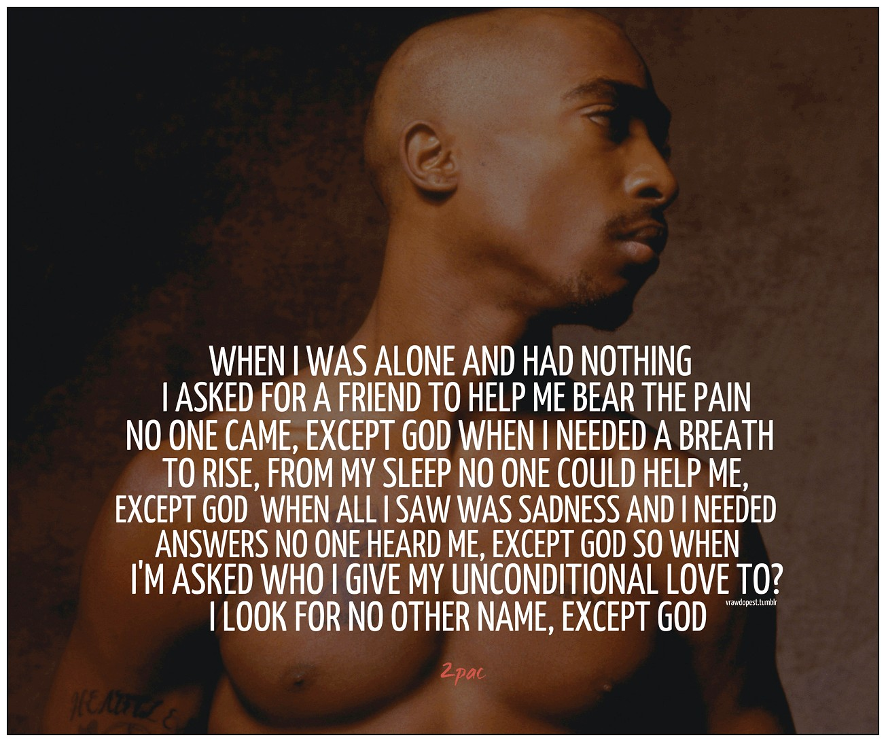
Week 1
INTRODUCTIONS
Words From A Prophet
Tupac at the Brotherhood Crusades
Tupac Speaks From the Heart
Tupac on Trump
Tupac at Arsenio Hall Show (1)
Tupac at Arsenio Hall Show (2 - 1993)
Tupac on Illuminati
Afeni Shakur - Dear Mama (1997)
I Wonder If Heaven Got A Ghetto
Listen to The Following Albums:
2Pacalypse Now (1991)
Strictly 4 My N.I.G.G.A.Z... (1993)
Me Against the World (1995)
All Eyez on Me (1996)

The Background
Week 2
Assata: An Autobiography
Tupac: Resurrection
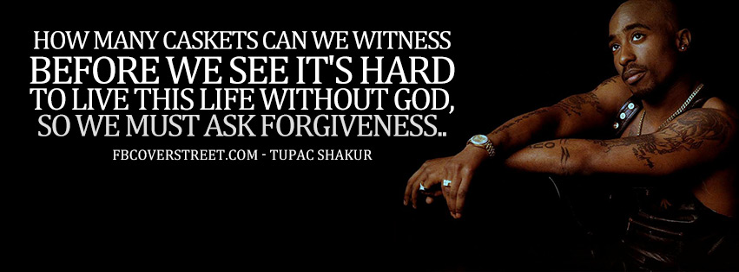
The Background
Week 3
Tupac Shakur: The Life and Times of an American Icon
Thug Angel: The Life of An Outlaw
Tef Poe Lecture: https://youtu.be/yrmSi3vEuIo
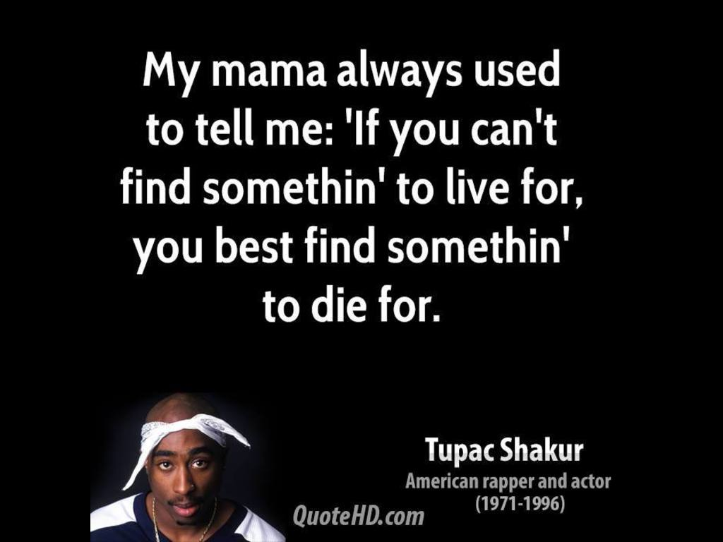
The Music
Week 4
The Rose That Grew From Concrete
Prison Interview
1996 KMEL Interveiw
The Last Interview – Thug Immortal

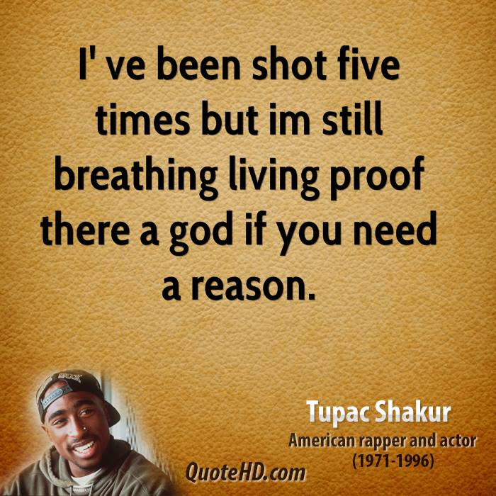
The Music & Faith (On Campus) (Interviews With Tef and Heather Brydie Harris)
Week 5
Inside Deathrow Records
Amateur Video
2Pac Greatest Hits
Listen to The Following Albums:
The Don Killuminati: The 7 Day Theory (1996) (as Makaveli)
R U Still Down? (Remember Me) (1997)
Until the End of Time (2001)
Better Dayz (2002)
Loyal to the Game (2004)
Pac's Life (2006)
The Faith
Week 6
Holler If You Hear Me: Searching For Tupac Shakur
Tupac’s Wisdom
Tupac on G*d and Religion
Tupac on G*d’s Curse (Vibe)
The Man
Week 7
Afeni Shakur: Evolution of a Revolutionary
Keisha Shakur Interview - 1997
Critique of All Eyez On Me – With Keisha Shakur
Kidada Jones
Left Eye Interview
Jada Pinkett Smith Interview
Jada and Tupac
The Man
Week 8
Thru My Eyes: Thoughts on Tupac Amaru Shakur in Pictures and Words
Tupac & Chuck Phillips: 1993
Tupac & Chuck Phillips: 1995
Lost Vibe Interview: 1996
MTV Interview: 1996
MTV Interview Collection: 1997
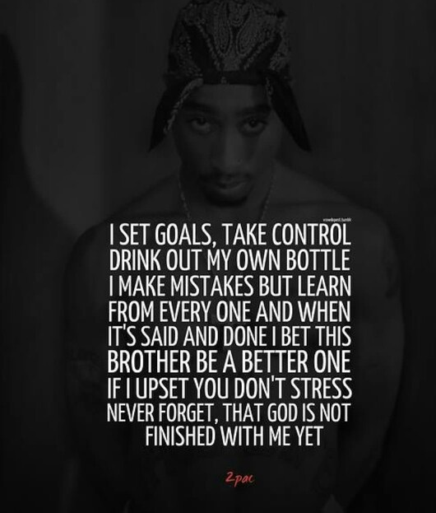
The Legacy
Week 9
Inside A Thug’s Heart
Biggie & Tupac: The Story Behind The Murder of Rap’s Biggest Superstars
Tupac: Assassination
All Eyez On Me
The Legacy
Week 10 – Final Presentations
Afeni Shakur on BET
Afeni Shakur Interview

